Setup
- Start the Eyelink Host PC application
  - Press Tracker
- Launch Eyelink from Display computer (click on desktop)
- Check the settings in Eye tracker
  - Eye Tracking settings: “Right eye”
  - Illumination level: 100%
  - Sample rate: choose 500 hz or 1000 hz
  - Calibration settings: Select number of calibration points
    - For us, 5 points are sufficient – you may want more depending on where your stimuli are and how fine grained you want it
  - Calibration control: Auto
    - If having trouble with the auto during calibration and/or validation, can try manual but I find auto is best as the tracker won’t allow the stimulus to move until the eye has stabilized
  - Advanced settings:
    - Pupil Size Data: ensure it is ON
    - Saccade Parser Sensitivity: High
- On the setup screen, click mouse on the eye and make sure the circles are around it and crosshairs are properly centered in the pupil
- Set Pupil and CR thresholds:
  - Select each eye (one at a time) and Click “Auto” first (below the threshold box) – if this looks good, keep it. If not, manually adjust the pupil such that the blue is confined to pupil and the CR based on images below
  - Manual adjustments are made by:
    - é arrow and ê arrow for the pupil
    - + and – for the corneal reflection
    - Side Arrow keys (ç and è): Toggle back and forth between eyes (only if using binocular)
  - Manual adjustments to pupil & CR can be done anytime throughout the calibration, validation, and actual recording
  - If the person is wearing glasses, might have to be more vigilant and careful about pupil & CR values and make sure during the recording you are paying attention and adjust accordingly (See note below)
- Before calibration: Test that the tracker is detecting the pupil (and keeping the tracking) by having the participant look to the four corners of the monitor and watch for potential pupil thresholding issues – if the tracker drops the eye, you might need to adjust things – you’ll know its not going to track well if you see the messages “PUPIL MISSING” or “CR MISSING” when they’re eyes are moving around

Calibration
- Instructions for participant: “You will see targets appear on a screen. Please make sure your eyes are wide open, and look at the target when it appears and stay there until you see another target appears, then look at it and stay there. Do this for all targets”
- Press C or click ‘calibrate’
- Press Enter or Spacebar to start the calibration
- Press A for the automatic calibration sequence
  - If auto is giving you trouble, can press ‘M’ to do manual (but I suggest automatic)
  - If manual is selected, you can click the ‘accept fixation’ button once the eye has stabilized on the target, or press spacebar, to accept fixation, then the dot will move to the next location
  - Ensure you’ve given enough time that the eye has stabilized, but not too much time that the eye breaks fixation, prior to accepting the fixation
- If calibration isn’t working out, and the cursor jumps or disappears intermittently, can click abort or press ESC, and you will have to go back and check camera settings, pupil and CR thresholds, and focus (see below). Then start again
  - If pupil is noisy or undetected at that position, and the eye tracker won’t present the next target until it is detected. If this happens, and you can’t overcome it by reminding the participant to open their eye and fixate the target, then press ESC twice to exit the calibration, adjust your values on the setup screen (pupil, CR, ensure focus), then restart calibration
- You can restart the calibration by clicking restart or pressing Delete
- If one point for calibration was particularly bad (eye very far from the target for example), can click ‘undo last point’ or Backspace to undo the last target and redo it
- A good calibration will have a grid shape that looks like the calibration you chose (so the five crosses look like the pattern they should look like – up, down, left, right, center). If these crosses are all over the place, unlikely to be a good calibration. See below note on ‘what a good calibration looks like’
- If calibration looks good, press ‘enter’ or click accept to accept calibration values

Do not press the ‘restart’ button or the ‘ESC’ button if you have a good calibration – this will cancel the calibration and will exit to the setup screen and you will have to start over.

Look out for these indicators. If the participant is looking at the screen and you see these messages, there is a problem with the setup and you should go back and adjust it.
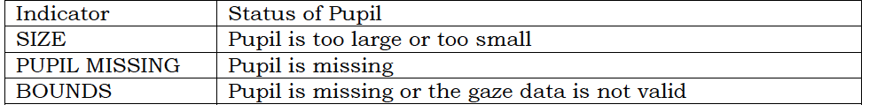

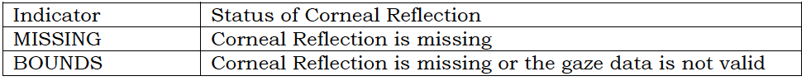

Validation
- Press V or click ‘validate’
- Press Enter or Spacebar to start the validation
- Press A for the automatic validation sequence
  - If auto is giving you trouble, can press ‘M’ to do manual (but I suggest automatic)
- If manual is selected, you can click the ‘accept fixation’ button once the eye has stabilized on the target, or press spacebar, to accept fixation, then the dot will move to the next location
  - Ensure you’ve given enough time that the eye has stabilized, but not too much time that the eye breaks fixation, prior to accepting the fixation
- If validation isn’t working out, can click abort or press ESC, or you can restart the validation by clicking restart or pressing Delete
- If one point for validation was particularly bad (eye very far from the target for example), can click ‘undo last point’ or Backspace to undo the last target and redo it
- A good validation will have a low error between the validated eye position and the calibrated eye position (look at the screen to see this – the line should be close between the calibrated & validated eye position)
  - See message on the bottom corner of the screen: you want “GOOD”, not “FAIR”/“POOR”
- If validation looks good, press ‘enter’ to accept calibration values.
- If validation doesn’t look good, and there is a large error between calibrated eye position and validated eye position, then you may need to go back and repeat the calibration and also check your focus, pupil & CR values
- Click ‘Record’ to start the eye tracker – OR recording is generally initiated by running your application on the display PC

Watch during the recording. If you find there is a lot of missing data (red dots, eye loss), stop and start again.

Drift Correct: Do not use drift correct as a calibration.
- Work to obtain a good calibration (it can be done with adjusting). Drift correct can be used between tasks/blocks, once a good calibration has been obtained, but should not be used in place of calibration. Its purpose is to correct for drift since the calibration was performed
- On the setup screen, click ‘apply correction’ or press D
- When the eye has stabilized, click ‘accept fixation’ or press Enter or spacebar
- Accept fixation if good (low error between initial eye position and drift corrected position)

Exiting Eyelink software
- CTRL + ALT + Q click shutdown button on the File Manager toolbar
- OR click “Exit” from the setup screen and choose “Exit” in the following dialog box
- Don’t turn off computer when Eyelink Host software is running because you could lose data

Extra Tricks:
If the person is wearing glasses and you are having a hard time, try:
- Advanced settings:
  - Use Search Limits: excludes regions of the camera image that might be detected as pupil/CR
    - If you use this, and the participant moves their head, may have to recheck the settings though!
    - Size of search limit area can be adjusted by pressing ALT and the cursor keys together (ALT + é arrow or ê arrow to adjust the height, ALT + ç arrow and right è arrow to adjust the width) – need to adjust for each eye separately

If in general you are having a very hard time, you can try:
- Advanced settings:
  - ‘Ellipse algorithm’ (instead of ‘centroid’)

More detailed information

What does a good set up look like:

Cross hairs aligned with pupil, dotted line falls between participants eyes, camera is in focus, pupil and CR thresholds are well-set:

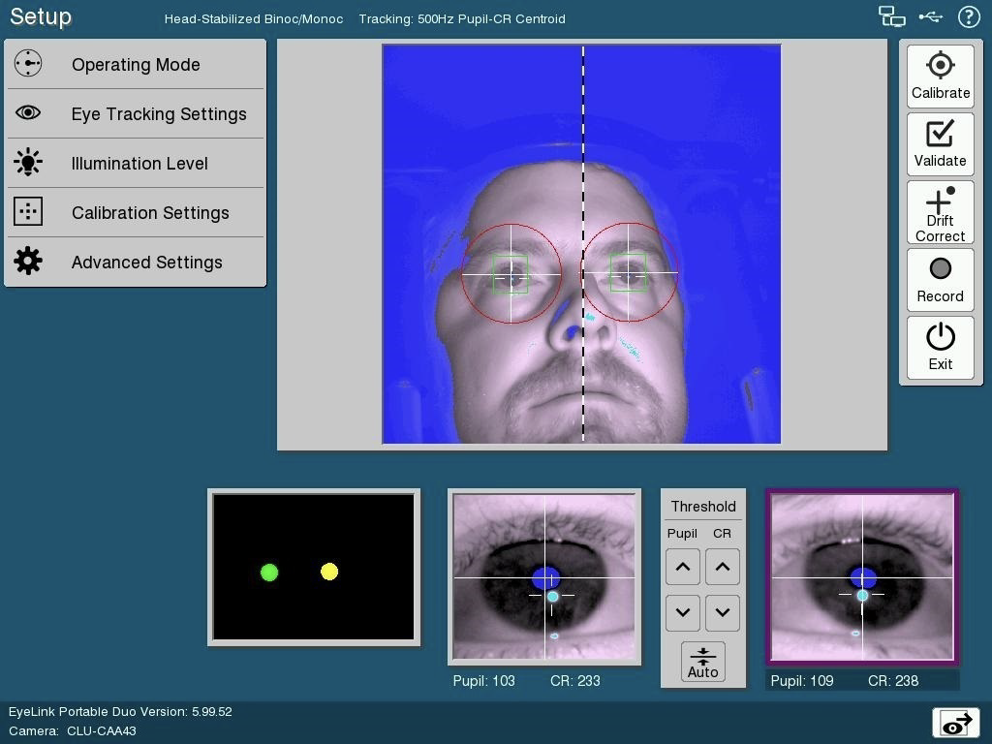

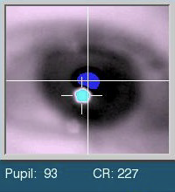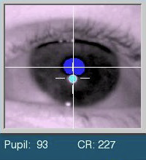
Bad focus Good focus

Pupil Thresholds:

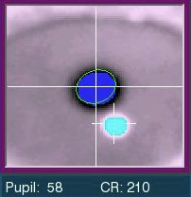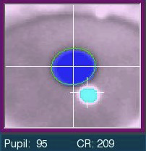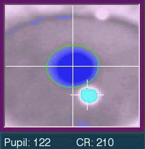
Too low Perfect Too high

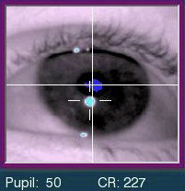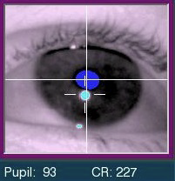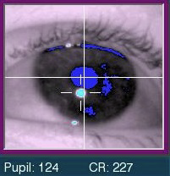
Too low Perfect Too high

CR Thresholds:

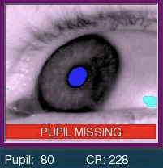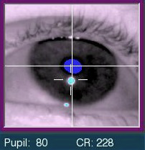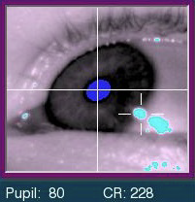
Poor Good Smearing

What does a good calibration look like:

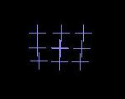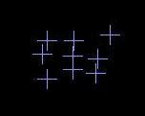
Good Poor

A good calibration will have crosses on the screen that look like what you would expect them to look like based on the calibration scheme you chose – if 5 point, should be up, down, left, right, center. If they are all over the place, restart.

Shortcuts & functions

